Hi buyer’s name,

I would like to introduce our new dress line: COMPANY NAME.

We hang with brands like Milly & Shoshana. Our dresses are made in USA and will definitely add a splash of color and freshness to your store!

As a contemporary label, our goal is to dress women in pieces that are different and that won't go out of style.

To give you an idea, below is one of the styles we carry. Most of our dresses are in the wholesale price range of $165 - 199.

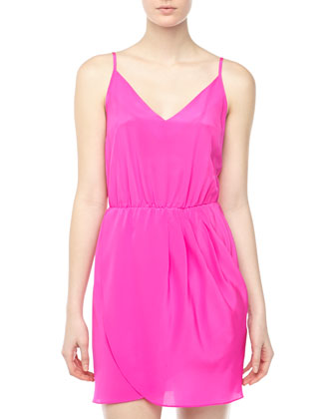

To see the full collection click here: LINK

Linesheet and Order Form, click here: LINK
Password: cookies

I'd love to hear from you! Can we schedule a ten minute (promise!) feedback session so we can discuss the line? We can chat on the phone, meet in person or I can send out samples for your review.

Thank you so much for your time!

P.S. I am a new designer working with a local production team with more than 20 years of experience. You will be in the best of hands, promise! Don't let the "new" part scare you, by new I really just mean different... and different we are indeed!

Sincerely,

Your Name

COMPLETE CONTACT INFO
​

